Informatica PowerCenter
Scenario-Based Interview Questions
With Expressions, Mapping Diagrams & Explanation

Scenario 1: Alternate Records / Odd-Even Records into 2 Targets
Route alternating records (odd-numbered and even-numbered rows) to two separate target tables.

Approach A: Using Sequence Generator + MOD Expression
- Add a Sequence Generator transformation to assign row numbers to each input record.
- In an Expression transformation, create a variable:
Remainder = MOD(NEXTVAL, 2)
- Add a Router transformation with 2 groups:
  - Group 1 (Even records): Remainder = 0
  - Group 2 (Odd records): Remainder = 1

Mapping Diagram – Approach A
Source | → | Seq Gen | → | Expression (MOD) | → | Router (2 grps) | → | Target1 Target2

Approach B: Without MOD – Using Cyclic Sequence Generator
- Enable the Cyclic property in Sequence Generator:
  - Start Value: 1
  - Increment By: 1
  - End Value: 2
  - Cyclic: Enabled (resets to Start after End)
- Add a Router transformation with 2 groups:
  - Group 1 (NEXTVAL = 1): 1st target
Group 2 (NEXTVAL = 2): 2nd target Src qualifier – no of sorted inputs 1 – so it will sort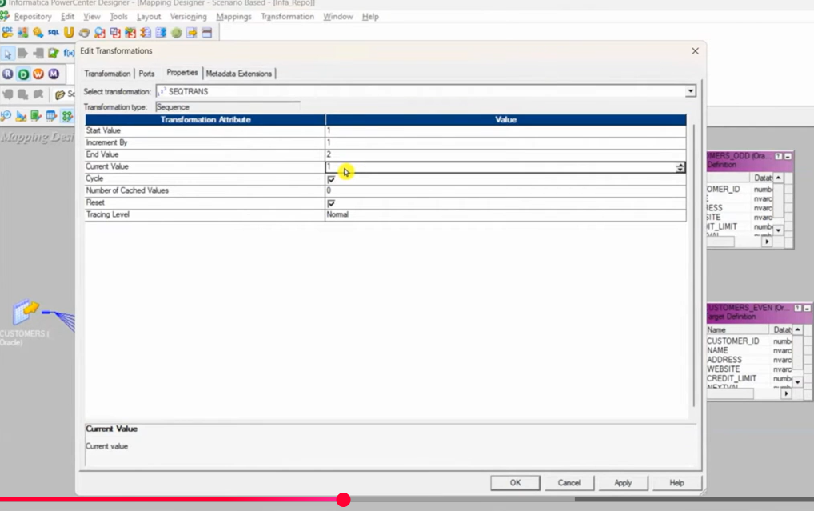 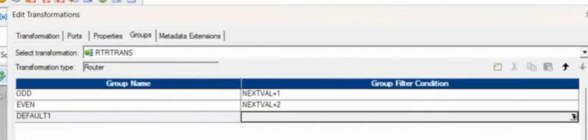 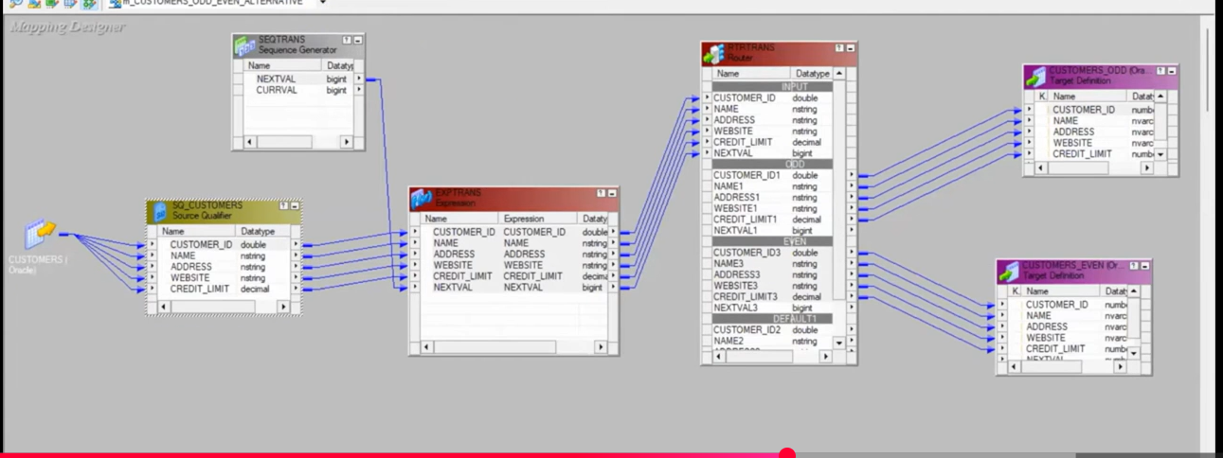

Mapping Diagram – Approach B
Source | → | Seq Gen (Cyclic 1→2) | → | Router (2 grps) | → | Target1 Target2

Scenario 2: Dynamically Create Flat File Targets Based on Input
Example: Input has dept_no or dept_name column. Create separate flat files for each department dynamically.

Solution: Transaction Control Transformation
- Sort the input data by department column first.
- In Expression transformation, create a flag port:
V_current_dept = Input.department
V_prev_dept = V_current_dept
Flag = IIF(V_current_dept = V_prev_dept, 'N', 'Y')
- The variable Flag port must be placed BETWEEN the two variable ports in the expression.
- Connect to Transaction Control transformation with the following options:
  - Continue Transaction
  - Commit Before ← creates new flat file
  - Commit After
  - Rollback Before
- Use 'Create Flag' option in Transaction Control to generate new file per department change.

Mapping Diagram
Source | → | Sorter (dept) | → | Expression (Flag) | → | Trans Control | → | Dynamic Flat Files

Scenario 3: How to Sync Source and Target – Delete and Insert Logic
Keep target in sync with source by applying upsert (update/insert) logic.

- Use Lookup transformation on target table to check if record exists. – src.id =lkp target.id if
- Use Update Strategy transformation to mark records as:
  - DD_INSERT – if record does not exist in target
  - DD_UPDATE – if record exists (matched on key)
  - DD_DELETE – for records to be removed

Updatee strategy: Expression: iif(isnull(LKP_ID),DD_INSERT,DD_UPDATE)

- Enable 'Treat source rows as: Data Driven' on the session.
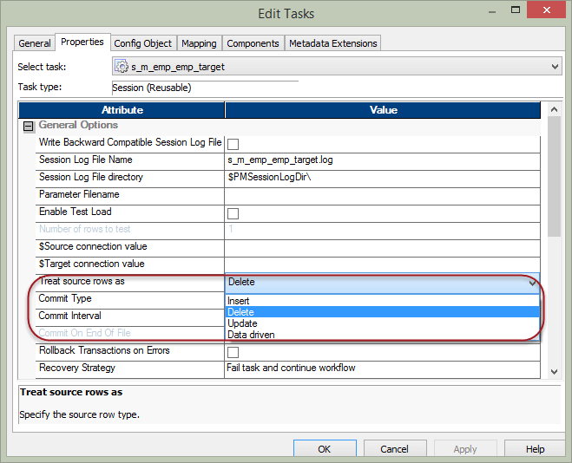

- For delete logic: use a flag in source or a separate pipeline to identify deletes.
SQL override in src qualifier – target -src or left join is null – connect to dd_delete in update strategy- This finds rows in the target that don’t exist in the source

Mapping Diagram
Source | → | Lookup (Target) | → | Update Strategy | → | Target (Upsert)

Scenario 4: SCD Type 2 Implementation
Slowly Changing Dimension Type 2 – maintain history of changes with new rows.

- Use Lookup on existing target dimension table (lookup on natural/business key).
- In Expression transformation, compare source and target columns to detect changes.
- Use Router or Filter to split into New Records vs Changed Records.
- For new/changed records:
  - Expire (close) old row: set End_Date = SYSDATE, Active_Flag = 'N' → Update Strategy DD_UPDATE
  - Insert new row: set Start_Date = SYSDATE, End_Date = NULL, Active_Flag = 'Y' → Update Strategy DD_INSERT

Mapping Diagram – SCD2
Source | → | Lookup (Dim) | → | Expression (Compare) | → | Router (New/Chg) | → | Upd Strat (INS/UPD) | → | Dim Target

Scenario 5: Load At Least One Occurrence per Alphabet + Duplicates to Separate File

Sorter asc - transformation

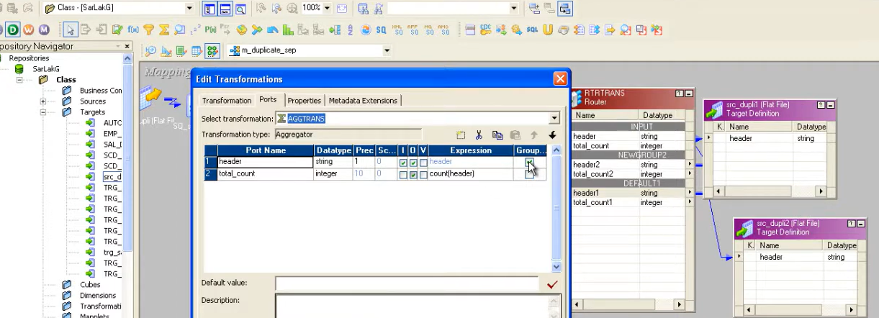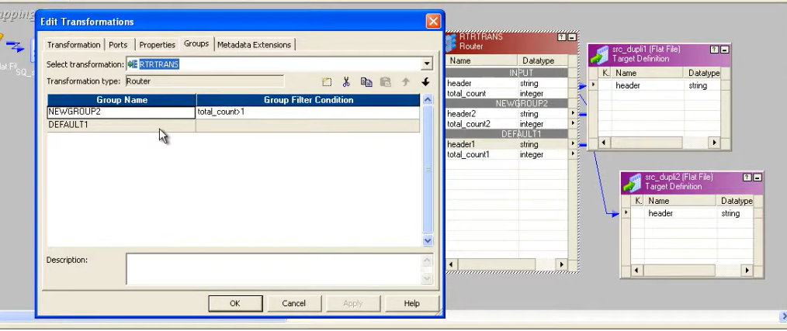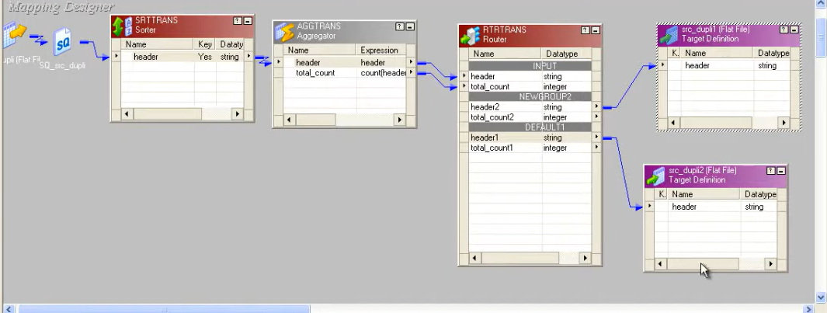

Scenario 6: Load NULL to First Record and First Record's Value to Next Record (Lead/Lag)
Shift values: Row 1 gets NULL, Row 2 gets Row 1's value, Row 3 gets Row 2's value, etc.

🧩 Step-by-Step Flow
- Row 1
  - V_CurrentValue = I_Col2 = 100
  - V_LastValue = IIF(ISNULL(V_CurrentValue), NULL, V_CurrentValue) → NULL (since no previous row yet)
  - Output Lag = NULL
- Row 2
  - V_CurrentValue = I_Col2 = 200
  - V_LastValue = previous V_CurrentValue = 100
  - Output Lag = 100
- Row 3
  - V_CurrentValue = I_Col2 = 300
  - V_LastValue = previous V_CurrentValue = 200
  - Output Lag = 200
📊 Port Setup (with intuitive names)
Port Type | Port Name | Expression | Purpose
Input | I_Col1 | Source Col1 | Pass Col1
Input | I_Col2 | Source Col2 | Pass Col2
Variable | V_LastValue | IIF(ISNULL(V_CurrentValue), NULL, V_CurrentValue) | Stores previous row’s Col2
Variable | V_CurrentValue | I_Col2 | Stores current row’s Col2
Output | O_Col1 | I_Col1 | Output Col1
Output | O_LagValue | V_LastValue | Output lagged Col2

Mapping Diagram
Source | → | Expression (Var ports for lag) | → | Target (Col1 + Lag_Col2)
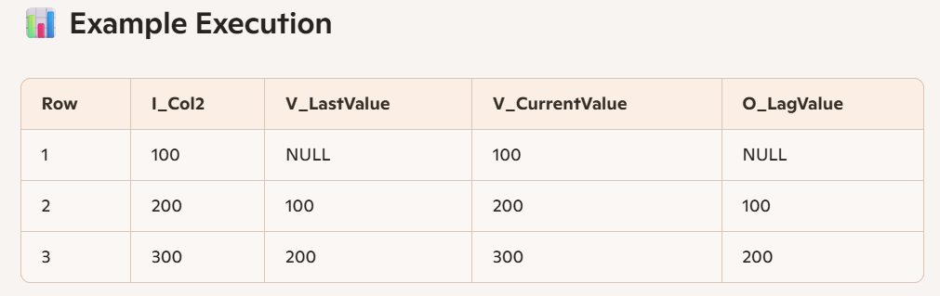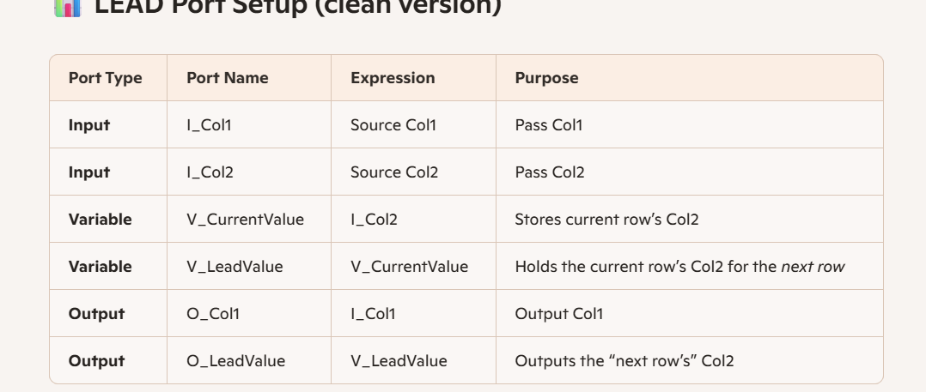

Scenario 7: Load Header and Footer into a Target Flat File
Use Rank transformation to separate header (first record) and footer (last record).

- Apply a Sequence Number to input using Sequence Generator.
- Use 2 Rank transformation on the sequence column:
  - Top Rank → captures the LAST record (highest NEXTVAL = greatest number)
  - Bottom Rank → captures the FIRST record (lowest NEXTVAL = smallest number)
- Why Sequence Generator is re-usable: it generates unique, ordered row numbers.
- Union both Rank outputs and write to the Target file in correct order.

Key Insight:
- When Top is enabled → Informatica arranges ranked port data in DESCENDING order
- When Bottom is enabled → Informatica arranges the data in ASCENDING order

Mapping Diagram
Source | → | Seq Gen (NEXTVAL) | → | Top Rank + Bot Rank | → | Union | → | Target Flat File

Scenario 8: Incremental Aggregation – Filling Gaps in Groups
Aggregate data across groups where some groups may be missing, using Rank 1–4 approach.

- Types of Cache: Persistent (used across sessions) vs. Non-Persistent.
- Rank 1-4 groups: each group receives incremental data.
  - Which is the Master value? The value mapped to the filter/update column.
- In Seq Generator: filter data with dept or Town column, set update strategy.
- If the file has current value mapped to Target → it will be updated.
- Instead of export → records are inserted.

Target Update Strategies
Strategy | Action | Use Case | Session Setting
DD_INSERT | Insert new row | New records | Normal
DD_UPDATE | Update existing row | Changed records | Data Driven
DD_DELETE | Delete the row | Removed records | Data Driven
DD_REJECT | Reject the row | Bad records | Data Driven

SCD Types Summary
Type | Description | Informatica Approach
SCD 1 | Overwrite – no history kept | Direct update via Update Strategy DD_UPDATE
SCD 2 | Add new row – full history | Lookup + Router + two Update Strategies (DD_UPDATE old row, DD_INSERT new row)
SCD 3 | Add column – partial history (prev value only) | Update Strategy: move current to 'previous' column, write new to 'current' column

Scenario 9: PK Defined at Informatica Level but Not at Table Level
Handling scenario where Primary Key is not enforced at the database level, but must be maintained in the ETL logic.

- Use a Lookup transformation on the target table with the business key column(s).
- If Lookup returns a match → record already exists → use DD_UPDATE.
- If Lookup returns NULL (no match) → new record → use DD_INSERT.
- This effectively enforces PK logic in the mapping without relying on DB constraints.
- For duplicates within source: use Aggregator or Sorter + Expression to de-duplicate before loading.

Scenario 10: Indirect File Loading
Load multiple source files using a single session by pointing to a control/index file.

- Create a text file (indirect file) that lists all source file names/paths, one per line.
- In the session's Source File settings:
  - Set File Type to 'Indirect'
  - Point the Source Filename to the indirect control file
- Informatica reads the control file, then loads each file listed within it sequentially.
- Use Case: Daily/monthly files named file_jan.csv, file_feb.csv, etc. – list them in a control file.

Scenario 11: Types of Joins in Informatica PowerCenter

Join Type | Description | Use Case
Normal Join | Inner join – only matching rows from both sources | Standard matching records
Master Outer Join | All rows from detail, matching rows from master | Detail is primary, master may not always match
Detail Outer Join | All rows from master, matching rows from detail | Master is primary, include nulls from detail
Full Outer Join | All rows from both sources | No data loss; includes unmatched from both sides
Note: Less records → Master, More records/Duplicates → Detail (in Joiner transformation).

Scenario 12: Performance Tuning

Step 1: Identify Long Running Sessions
- Go to the Monitor → find sessions with high execution time.

Step 2: Analyze Session Log
- Get the session log and look for the 'Session Load Summary'.
- It will show thread-level breakdown:
  - (i) Reader Thread
  - (ii) Writer Thread
  - (iii) Transformation Thread

Step 3: Check Busy Percentage
- Look for Busy % for each thread.
- If Busy % is HIGH → Idle time will be LOW → Bottleneck is identified at that particular thread.

Bottleneck Thread | Root Cause | Fix
Reader Thread | Source DB slow; large source data | Partitioning, push-down optimization, filter at source
Transformation Thread | Complex expressions, large lookups | Use persistent cache, optimize expressions, remove unused ports
Writer Thread | Target DB slow; bulk load off | Enable bulk load, increase commit interval, use pre/post SQL

Scenario 13: Range Partitioning
A technique that allows large tables to be divided into smaller, more manageable pieces called partitions.

- Range Partitioning divides data based on a range of values in a column (e.g., date ranges, ID ranges).
- In Informatica: configure partition keys under the session's partition settings.
- Use Case: Monthly sales data partitioned by date range per month.
- Benefits: Faster query performance, easier data archiving, parallel processing.
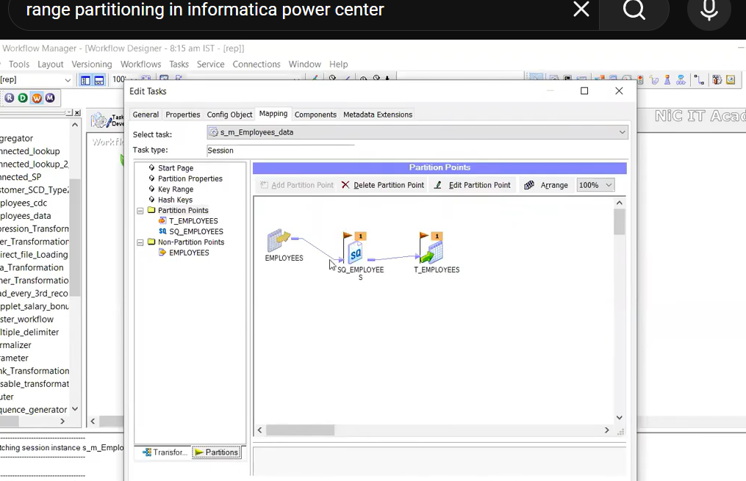

- 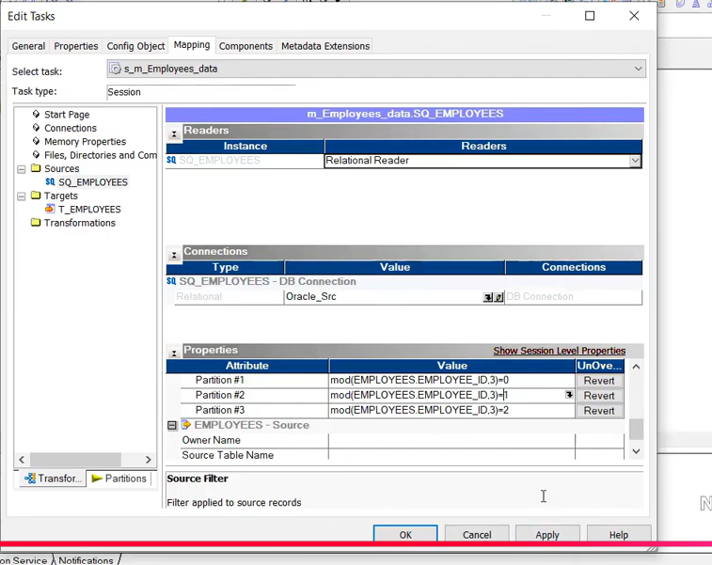
Range 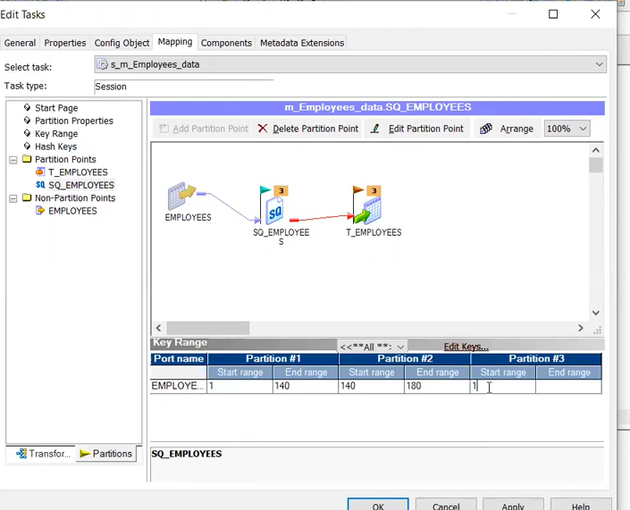

Quick Reference: Common Transformations Used
Transformation | Purpose | Key Property
Sequence Generator | Generate unique row numbers / IDs | Cyclic: restarts after End Value
Expression | Row-level calculations, conditionals | Variable ports for inter-row logic
Router | Split data into multiple groups | Default group for unmatched rows
Sorter | Sort data for aggregation/comparison | Distinct: remove duplicates
Aggregator | Group-level aggregations (SUM, COUNT) | Sorted input improves performance
Lookup | Reference data from DB or flat file | Connected vs. Unconnected; Persistent cache
Rank | Top/Bottom N records | Top = highest; Bottom = lowest
Joiner | Join heterogeneous sources | Master (fewer rows) + Detail (more/duplicates)
Update Strategy | Flag records for Insert/Update/Delete | Session must be set to Data Driven
Transaction Control | Dynamic commit / rollback logic | Create new flat file on Commit Before
Union | Merge multiple pipelines | All inputs must have same port structure

